Ex. No. : 10 | Date:
Register No.: 231701501 | Name: Sri Vishnu K

PCA (Dimensionality Reduction)
Aim:
To implement Principal Component Analysis (PCA) for dimensionality reduction on the Iris dataset.
PROGRAM:
import pandas as pd
import numpy as np
import matplotlib.pyplot as plt
from google.colab import files
from sklearn.preprocessing import StandardScaler, LabelEncoder
from sklearn.decomposition import PCA
# Upload dataset
uploaded = files.upload()
# Load dataset
data = pd.read_csv("Iris.csv")
# Drop Id column if present
if 'Id' in data.columns:
data = data.drop('Id', axis=1)
# Split features and target
X = data.iloc[:, :-1].values
y = data.iloc[:, -1].values
# Encode target labels
le = LabelEncoder()
y = le.fit_transform(y)
# Standardize features
scaler = StandardScaler()
X_scaled = scaler.fit_transform(X)
# Apply PCA (reduce to 2 dimensions)
pca = PCA(n_components=2)
X_pca = pca.fit_transform(X_scaled)
# Explained variance
print("Explained Variance Ratio:", pca.explained_variance_ratio_)
# Plot PCA result
plt.figure()
plt.scatter(X_pca[:, 0], X_pca[:, 1], c=y)
plt.xlabel("Principal Component 1")
plt.ylabel("Principal Component 2")
plt.title("PCA on Iris Dataset")
plt.show()

OUTPUT :

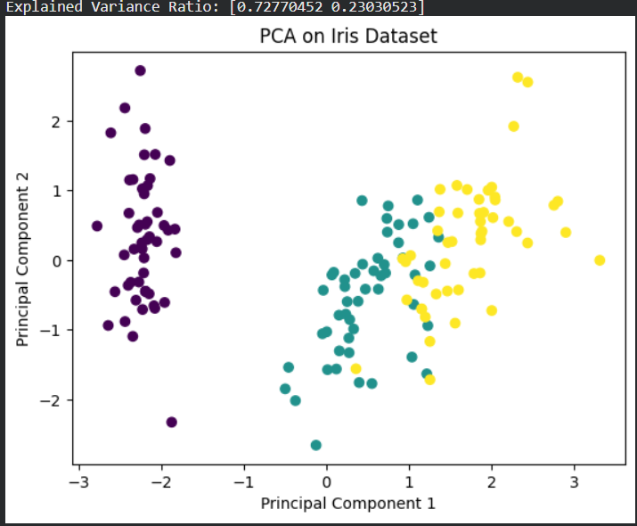

Result:
PCA successfully reduced the dataset from higher dimensions to two principal components while retaining most of the variance.

